Requirements/Design Specification

**Approval Email Layout**

Revision History

|  |  |  |  |
| --- | --- | --- | --- |
| **Date** | **Revision** | **Description** | **Author** |
| 10/21/2014 | 1.0 | Initial Version with Requirements | Roger |
| 10/28/2014 | 1.1 | Added feedback from team | Roger |
| 11/4/2014 | 1.2 | Modifications based on team feedback and mockups for Disposal Site and Time | Roger |
| 11/6/2014 | 1.3 | Final Changes Completed | Roger |
| 2/9/2015 | 1.4 | Updated based on GitHub | Julie |

The information furnished herein by Republic Services Inc. is proprietary and confidential to Republic Services Inc. personnel and is not to be duplicated, published, or disclosed to any third party in whole or in part without permission from Republic Services, Inc.

© Copyright 2012, Republic Services Inc. - All rights reserved.

Table of contents

1 Business Requirements 6

1.1 Purpose of the Design Specification 6

1.1.1 Business Functional Requirements / Configuration 6

1.1.2 Technical Design Requirements 7

2 Assumptions 8

3 Technical Design 9

3.1 Referenced Documents 9

3.2 Process Flow and Mock Ups 9

3.3 Functional Logic 11

3.4 Data Sources & Mapping 11

3.5 InfoPro Interface 11

4 Report Changes 11

5 Appendix 11

# Business Requirements

## Purpose of the Design Specification

This document highlights items to be implemented for Rate Restriction functionality. In order to get certain functionality to the users quicker, not all items will be implemented in this first iteration.

### Business Functional Requirements / Configuration

| **Business Functional Requirement** | **Notes** |
| --- | --- |
| Config Page and/or Config Templates | No Changes |
| Commerce: | No Changes |
| Documentation   * CSA, Proposal, Sample Invoice | No Changes |
| 1. Approvals | * In Salutaion and Submitted By, change from user_id to name of approvers * Add Approval Reason. Reason should be in red letters if below cost * Add link to customer name to the big maps. See example in mockup. * Add Industry, Segment, Terms and Rate Restriction * Add Number of containers * Add additional Items * Make Op Inc, Margin % and Direct Cost %. Make red when negative |
| Approvals – update approval email content for small container | Small Container   * Margin over direct cost (break out cash cost) * Asset Value for compactor * Lbs/yd used for pricing - (need dev work) * Service Time/Lift - (need dev effort) * Disposal Site |
| Approvals – update approval email content for large container | Large Container   * Rate/Haul vs. Cost/Haul * Rate/Ton vs. Cost/ton * Margin over direct cost * Asset Value for compactor * Total Service Time (and maybe broken out by details) * Tons/load assumed * Disposal Site |

### Technical Design Requirements

*Not yet complete, will complete once functional requirments are approved.*

| **Technical Design Requirement** | **Notes** |
| --- | --- |
| Config (Select Service Offering) page | No Changes |
| Commerce | * Create new email notification generator function * Add new variables and modify HTML accordingly * No change to approval rules |
| 1. Container Details | * Compactor Asset Value (currency) * compactorValue * Compactor Asset Value (currency) * “N/A” (small container) * totalPrice_line (large cont) * Rate Per Haul |
| Documentation   * CSA * Proposal * Sample Invoice | None |
| InfoPro Interface | None |

# Assumptions

The following items are out of scope

* **ROI (ROI is already part of Op Inc)** – The new cost model uses two measures of profitability, and we would like to drive everyone to thinking about the financial value of any deal using these measures.
  + (1) a “Cost” guardrail that if used to calculate margin, will generate a direct cost margin.
  + (2) a fully loaded “Margin %”  that appears in the financial summary.
* **Rate/Yd (quick glance at quality)** – Rate per yard can vary widely depending on the size of the container and the frequency of service, and this rate has very little relationship to profitability or quality of revenue without understanding the costs associated with the underlying service.  The “Cost” guardrail is the most accurate measure of the quality of revenue and is a better indication of profitability than the price per yard.
* **Disp Cost / Ton for that service area for Commercial**
  + The “Cost” guardrail has the disposal cost embedded in it for the customer
  + The “Disposal Expense” line item has the I/C disposal expense for the customer.  This is the area a manager should refer to in order to determine if disposal expense is appropriate for the customer.
* **Avg sale per yard (do not have) -** Similar to rate per yard, this can lead to misleading comparisons depending on size and frequency.  The intent of the guardrails is to set a range of pricing options that should be the main point of reference for a manager in determining how far from “average” the proposed price is.  Guardrails are customized to the size, frequency and business rules selected so are the very best indication of RSG’s desired revenue from that specific configuration.
* **Cost per hour used** – Cost per hour does not include many elements of cost including container maintenance and depreciation, truck depreciation, commission expense, and cost of capital.  If managers use only the cost/minute to try and evaluate proposed price, costs will be significantly underestimated.  The “Cost” guardrail provides the best measure of the direct cost of the haul.  This number can be divided by the estimated minutes to get a cost per hour that includes all direct costs.

# Technical Design

## Referenced Documents

None

## Process Flow and Mock Ups

Below is a content mock up of the approval email. The blue text indicate new or changed verbiage.

-------------------------------------------

Dear behmro (display name instead of id),

Quote A149452, test requires your approval for the following reason(s):

**Core price set outside guardrails**

*Quote Detail:*

|  |
| --- |
| Submitted By: behmro (display name instead of id) |
| Submitted Date: 2014-10-21 00:00:00 |
| Comments: I need an approval. This is good business  Price Band: BELOW FLOOR |
| Quote Description: |
| Sales Activity: New/New |
| Division Number: 4753 |
| Customer Name: [Test Customer](http://www.bing.com/maps/default.aspx?rtp=pos.42.2_-122.3) (make a link to the address to bing maps) |
| Competitor: |
| Industry: |
| Segment: |
| Term: |
| Rate Restriction:   * Restriction details outlined on CSA |

Container Details:

|  |  |  |  |  |  |  |
| --- | --- | --- | --- | --- | --- | --- |
| **Container** | **Compactor**  **Asset**  **Value** | **Total**  **Service**  **Time** | **Rate**  **Per**  **Haul** | **Cost**  **Per**  **Haul** | **Tons**  **Per**  **Haul** | **Disposal**  **Site** |
| FRONT LOAD 8 YARDS,Solid Waste,1/Week,Base |  |  |  | N/A | N/A |  |
| ROLL OFF 20 YARDS,Solid Waste,On-Call,Haul |  |  | [Calculted in utils] | [Calculted in utils] | Config/estTonsPerHaul | Config/landfillCode_readOnly |

Quote Totals:

|  |  |  |  |  |  |
| --- | --- | --- | --- | --- | --- |
|  | **Cost Price** | **Floor Price** | **Average Price** | **Target Price** | **Proposed Price** |
| Small Containers | $48.79 | $107.50 | $121.75 | $150.00 | $93.25 |
| Large Containers | $206.44 | $299.00 | $331.00 | $362.00 | $310.00 |
| Fees | $88.26 | $138.01 | $153.22 | $172.71 | $136.94 |
| Total Estimated Amount | $343.49 | $544.51 | $605.97 | $684.71 | $540.19 |

Financial Values:

|  |  |  |  |  |  |
| --- | --- | --- | --- | --- | --- |
|  | **Small Container** | | **Large Container** | | **Total** |
| **Solid Waste** | **Recycling** | **Solid Waste** | **Recycling** |
| Revenue | $126.61 | $0.00 | $413.58 | $0.00 | $540.19 |
| Disposal Expense | $38.12 | $0.00 | $149.04 | $0.00 | $187.16 |
| Net Revenue | $88.49 | $0.00 | $264.54 | $0.00 | $353.03 |
| Operating Expense | $58.72 | $0.00 | $181.06 | $0.00 | $239.78 |
| Op Income $ | $29.77 | $0.00 | $83.48 | $0.00 | $113.25 |
| Margin % | 23.51% | 0.0% | 20.19% | 0.0% | 20.96% |
| Direct Cost % |  |  |  |  |  |

Service Details:

|  |  |  |  |  |  |  |  |  |
| --- | --- | --- | --- | --- | --- | --- | --- | --- |
| Service | Cost | Floor | Average | Target | Price | FRF | ERF | Total |
| FRONT LOAD 8 YARDS,Solid Waste,1/Week,Base | $48.79 | $107.50 | $121.75 | $150.00 | $93.25 | $19.03 | $12.71 | $124.99 |
| FRONT LOAD 8 YARDS,Delivery | $0.00 | $55.00 | $55.00 | $55.00 | $55.00 | $10.85 | $7.24 | $73.09 |
| ROLL OFF 20 YARDS,Solid Waste,On-Call,Haul | $94.95 | $114.00 | $146.00 | $177.00 | $125.00 | $24.65 | $16.46 | $166.11 |
| ROLL OFF 20 YARDS,Solid Waste,On-Call,Disposal | $19.66 | $38.00 | $38.00 | $38.00 | $38.00 | $7.49 | $5.00 | $50.50 |
| ROLL OFF 20 YARDS,Solid Waste,On-Call,Rental | $32.85 | $33.00 | $33.00 | $33.00 | $33.00 | $6.51 | $4.35 | $43.85 |
| ROLL OFF 20 YARDS,Delivery | $0.00 | $55.00 | $55.00 | $55.00 | $55.00 | $10.85 | $7.24 | $73.09 |

Additional Items:

|  |  |  |  |
| --- | --- | --- | --- |
| Description | **Quantity** | **Total Price** | **Billing Method** |
| RCC | 1 | $150.00 | Monthly |

Container Comparison:

|  |  |  |  |  |  |  |
| --- | --- | --- | --- | --- | --- | --- |
| **Old Container** | **Size** | **Nbr** | **Waste Type** | **Frequency** | **PRICE** | **Fees** |
| FRONT LOAD 8 YARDS,Solid Waste,1/Week,Base | ***Config/containerSize_readonly*** | ***Config/quantity_readonly*** | ***Config/wasteType_readonly*** | ***Config/liftsPerContainer_readonly*** |  |  |
| ROLL OFF 20 YARDS,Solid Waste,On-Call,Haul | ***Config/containerSize_readonly*** | ***Config/quantity_readonly*** | ***Config/wasteType_readonly*** | ***Config/liftsPerContainer_readonly*** |  |  |
| **New Container** | **Size** | **Nbr** | **Waste Type** | **Frequency** | **PRICE** | **Fees** |
| FRONT LOAD 8 YARDS,Solid Waste,1/Week,Base | ***Config/containerSize_sc*** | ***Config/quantity_sc*** | ***Config/wasteType_sc*** | ***Config/liftsPerContainer_sc*** |  |  |
| ROLL OFF 20 YARDS,Solid Waste,On-Call,Haul | ***Config/containerSize_sc*** | ***Config/quantity_sc*** | ***Config/wasteType_sc*** | ***Config/liftsPerContainer_sc*** |  |  |

In addition to the approval email enhancements we will also show the fees section previously omitted on the approval page as well as adding the disposal site and minutes to the line item grid. Note the disposal site will need to be truncated to 50 characters in order to fit minutes.

-------------------------------------------

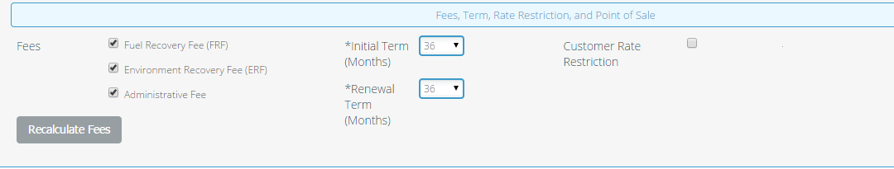

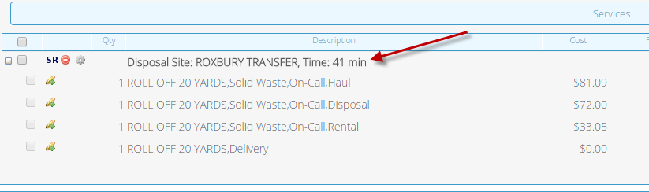

## Functional Logic

NA

## Data Sources & Mapping

* For detailed mapping information, please refer to the BMI [Enterprise Mapping Document](http://itpmo-2013projects/Pricing%20Initiative/2.0%20Planning%20and%20Requirements/BMI%20Enterprise%20Mapping%20Document.xlsx).
* No additional data sources or mappings needed

## InfoPro Interface

N/A

# Report Changes

No Changes

# Appendix